Unit 5_Phase End Project

Quick Documentation and Notes as I go:
- Here is my outline so far (note: I am not sure what main.js is supposed to be for – I will probably go ahead and delete that.)
- I can’t remember if I installed EJS or not. I am almost certain that I am 100% using Pug instead of EJS for this project.

Folder: cypress
- errors.cy.js
  - Checks to make sure the 404 Error Catch is working
- spec.cy.js
  - Runs the following tests:
    - Check that login page loaded correctly by verifying the title:
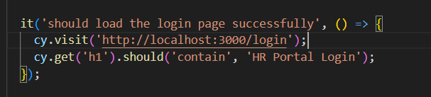
    - Make sure employees are displayed on the directory (note that this will be reading from the test mock data, so that it stays consistent and is not changed if the application users adds or removes data from the running JSON files. Because I am using Pug, I cannot stub data).
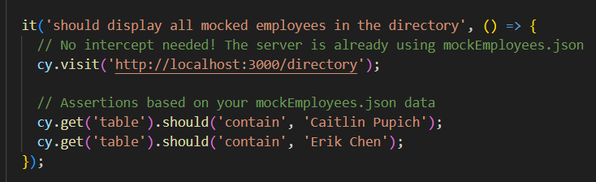
    - This will create an employee, check it has been created, then delete that employee (which will keep the testing JSON employee file clean)
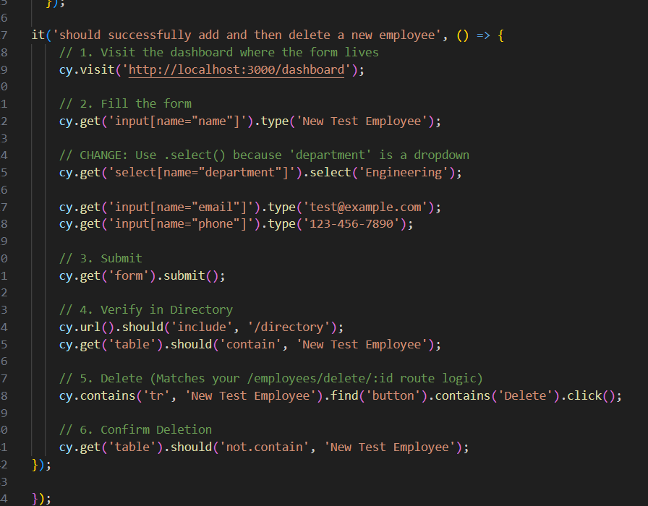
    - Test sign up and login (creating and calling a user on the test admin JSON file):
      - At the top, you will see that we clean up the file before each test so it does not change the data during the test.
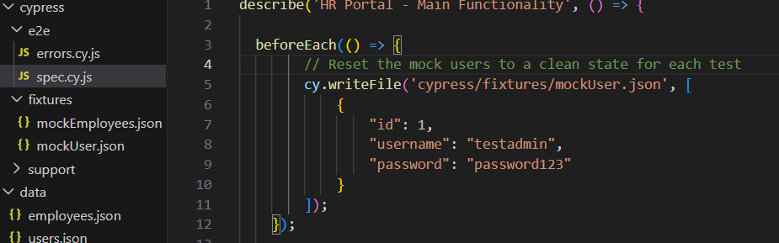

Folder: data
Data will be stored, modified, and pulled from this folder.

employees.json
This is where all the data will be stored for the employees. All CRUD operations will update to and pull from this document for employee information.

user.json
For the purpose of this project, all new users created will also be stored in their own JSON file. Creating a user will add it to this file.

Folder: public
This includes:
- css: for styling.
- Although this does not include anything else for this specific application, I wanted to include it since it is a normal layout folder to include things such as css, jpegs, other static files.

Folder: src

models
- dataManger.js: manages CRUD operations (using fs) between the website and the “database” (mocked with the JSON files in this case).
- The functions defined in this page will be used within the Routes.
- Note on testing data: because I am using Pug to render, I cannot stub data, so instead I have set it up to read the test data docs (for data and test consistency). Otherwise, it will run the normal docs.
  - 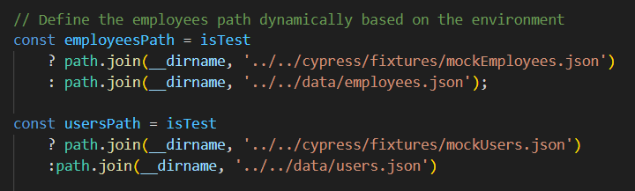
  - The test server to run with Cypress tests can be run with test:server, as defined in the package.json doc: 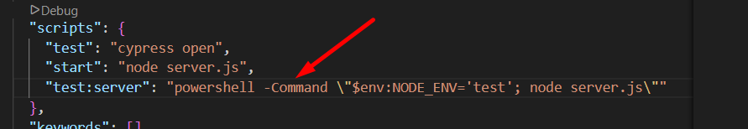

routes
manage and control the different routes and route groups used throughout the application. It uses the functions defined in models (dataManager.js). There are two route groups:
- authRoutes.js
  - Routes Handled
    - “/signup”
    - “/login”
    - “/dashboard”

hrRoutes.js
Routes Handled
- “/directory”
- “/employees/add”
- “employees/delete/:id”
- “dashboard”

Views
NOTE: I decided to use Pug instead of EJS to render the pages since we went over Pug in more detail throughout our lessons.
This contains all the pug files that will render the pages we need on the client side
- Layouts: includes main-layout.pug that will be used on all the Pug pages
- dashboard.pug
- directory.pug
- index.pug
- login.pug
- signup.pug

app.js
Runs the main application
- Assigns Express “view engine” to pug
- Assigns Express “views” to our “views” folder with the pug files
- Middleware
  - express.urlencoded
  - express.json
  - Router Level Middleware Groups
    - authRoutes
    - hrRoutes

server.js
This sets up the server and displays successful set up in the terminal for the development side. We will be using local host port 3000 for this project.

